Solution Architecture

Date | July 9 2026
Project Name | FinWise AI
Maximum Marks | 5 Marks

Solution Architecture Diagram:
Provide a high-level visual representation of your solution's architecture. Use the structural layout below as a template to map out your Presentation Layer, Application Layer, and Data Layer. Fill in the specific technologies and components for your project directly into the boxes to create your architectural diagram.


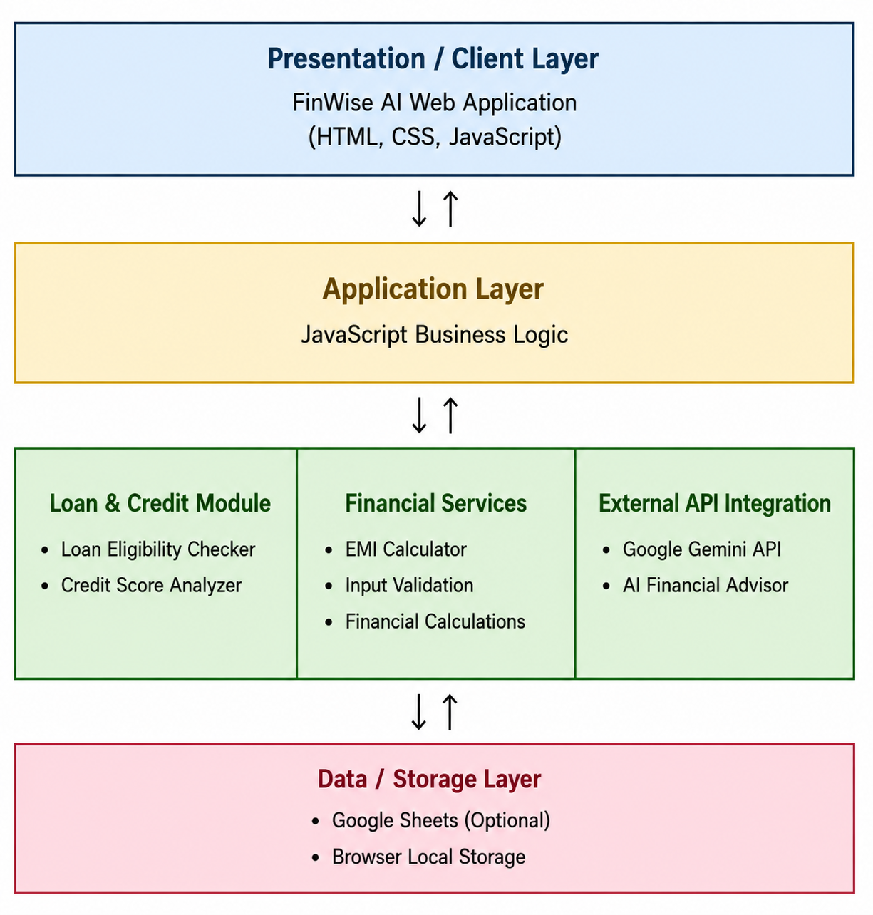



Component Description Table

Component Name | Description / Role in Architecture | Technologies Used
Presentation Layer | Provides the user interface for entering financial details and displaying results. | HTML, CSS, JavaScript
Application Layer | Processes user inputs, performs loan eligibility, credit score, EMI calculations, and communicates with Gemini API. | JavaScript
External API | Generates AI-powered financial advice based on user queries. | Google Gemini API
Data Layer | Optionally stores loan eligibility records and manages user input data. | Google Sheets (Apps Script), Browser Memory

